Title of Oral/Poster Presentation
Elizabeth C. Smith¹, Alexander B. Grohman², and Pat Z. Laroche*¹
¹University of ABC, 123 Lakeshore Blvd, City of ABC, ON M2P 3X2
²XYZ University, 1000 Pond Road, Town of XYZ, QC G8K 2M9

E-mail of presenting author: ecsmith@chem.uabc.ca
E-mail of corresponding author: pzlaroche@chem.uabc.ca

We describe a novel technique for creating abstracts for this conference, which will be shown in this template. This procedure enables researchers to copy and paste their own text into the template and thus have a simple and enjoyable conference registration experience. Importantly, the use of a template gives rise to multi-functional abstracts, which can be employed in understanding each presenter’s research prior to hearing their talk or viewing their poster. We go on to show how coherent text can be essential in the understanding of the research which is going on in the field of inorganic chemistry, and thus we can promote discussion throughout a wonderful weekend of networking and interaction between colleagues. It is important that the use of references be consistent with this formatting, and that the fonts be identical.^{[1]} We then describe a technique for sending in your abstract, by asking you to email it in PDF format with the filename based on the convention found on the webpage (http://idw.info.yorku.ca/abstract) to IDW2013@yorku.ca with either "Abstract - ORAL" or "Abstract - POSTER" as header of the email message. In the present case, the file would be named "UBAC_Laroche_Smith.pdf". Thank you so much for your interest in our conference. We hope you will join us and help us make the 46th Inorganic Discussion Weekend (IDW) at York University one of the best ever.^{[1,2]}
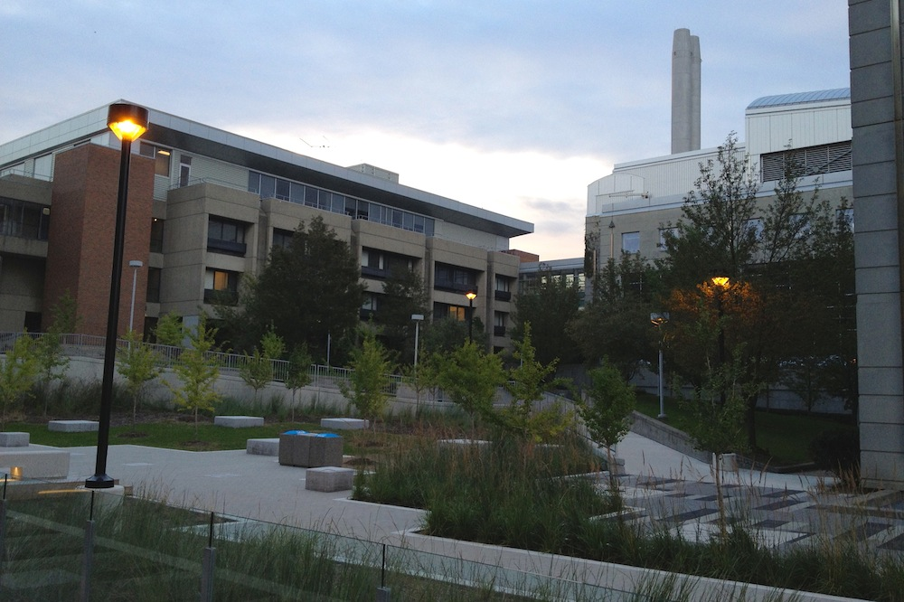
Figure. Chemistry Research Laboratories at York University (buildings shown herein: Petrie Science and Engineering (PSE) and Chemistry (CB); taken from the new Life Sciences (LSB) building).

References:
[1] Conference Registration Made Easy, by Smith and Smith (from the publishers who like to give you books by authors with the same name).
[2] The University of Ottawa, a Welcome Guide, L. Carroll ed., (Oxford, 1865).

